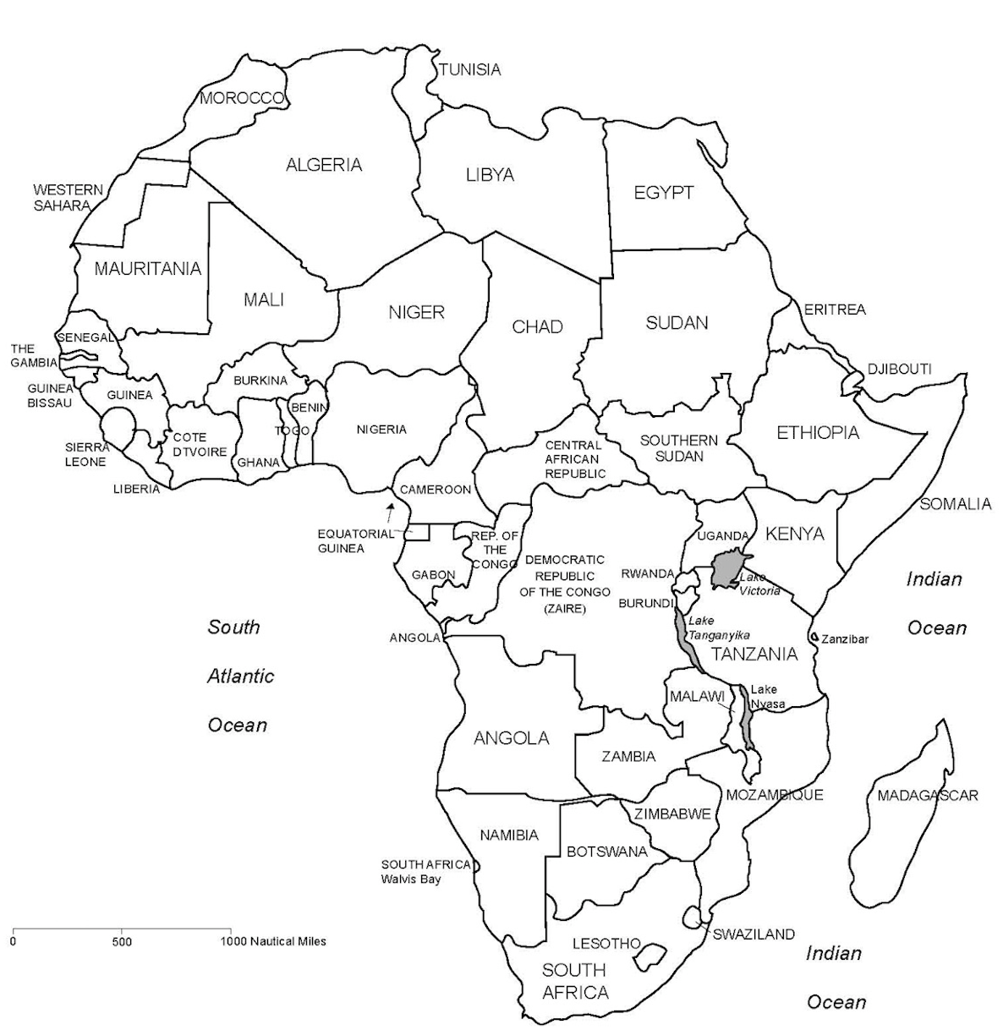
Mediterranean Sea
Cape of Good Hope

Vocabulary Term | Definition & Information
DESERTIFICATION | The gradual transformation of habitable/fertile land into desert, typically as a result of drought, deforestation, or inappropriate agriculture.  Issue affecting many areas in Africa. If countries don’t start to prevent or reverse the effects, desert regions could increase in size.
FAMINE | A negative effect of desertification. Many countries experience this because of poor economies.
DROUGHT | A negative side effect of desertification.
DEVELOPING COUNTRY | A poor agricultural country that is seeking to become more advanced economically and socially.  Most countries in Africa that we are studying would be considered developing because of their low standards of living and poor economies.
SAVANNA | A grassy plain in tropical and subtropical regions, with few trees where with much wildlife.  Tourist attraction for many of the countries. A way of making money for some countries. Need to keep certain animals off watch lists.

DESERTIFICATION
The gradual transformation of habitable/fertile land into desert, typically as a result of drought, deforestation, or inappropriate agriculture.

Causes | Negative Effects | Prevention | Reversing the Effects
Overgrazing  Too many animals feeding in one location | Vegetation is lacking or damaged  Damaged lands | Animals on the land must be reduced  Mixed farming & rotating crops – the same should be used for animal grazing | Management and policy approaches that promote sustainable resource use
Deforestation  The destruction of forests and grasslands | Erosion of soil  Food Loss  Soil is unusable | Soil conditions must be made better with natural fertilizer  Planting trees, perennials, and leguminous plants | Reintroducing selected species of plants  Establishing seed banks  Countering erosion – use of terraces
Over  Population  Too many people and not enough land to produce enough food | Poverty  Famine  Cannot support life | Better farming practices  Establish a culture of prevention | Enriching soil with nutrients
Climate  Change  & Drought | Animals die from starvation  Severe Floods | Better water conservation through irrigation | Establishing regulations and practices to support sustainable use of the land

SOCIAL: Information about people and society
- Over 800 different ETHNIC GROUPS in Africa (ex. Hutu and Tutsi)
- This makes it very difficult to form unified nations
- Over 1000 different LANGUAGES, 40 of which have more than one million speakers
  - The most multilingual continent in the world
  - Many speak fluently in multiple African AND European languages
- Over 40% practice a wide variety of TRADITIONAL RELIGIONS
- Life Expectancy = 58 years
  - Much lower in poorer countries, but higher in more developed countries
  - Reasons for low life expectancy
    - Malnutrition, Famines, Warfare, Poverty, Poor sanitation, Inadequate medical services
    - Disease (AIDS, Ebola, Malaria, TB, Yellow Fever)
    - Typical sub-Saharan MEAL (DAILY LIFE) includes:
  - Starchy food (rice, cassava, or corn cooked into a porridge, or yams)
  - Sauce containing vegetables or bits of meat
  - Plantain (large, starchy kind of banana that can be fried, boiled, baked or grilled)

ECONOMIC: Information about money, wealth, & trade
- Africa has the least developed economy of any continent (except Antarctica)
- Agriculture is the leading economic activity
  - Most farmers use outdated tools and methods of farming
  - Soil is thin and poor
- Africa has great mineral wealth
  - Huge deposits of copper, diamonds, gold, and petroleum
- Produce most of the world’s cassava, cocoa beans, and yams

ENVIRONMENTAL: Information about geography & natural resources
- Major Rivers
  - Nile River
  - Niger River
  - Congo River
- Important Geographic Features:
  - Mt. Kilimanjaro
  - Congo Basin
  - Deserts (Sahara, Kalahari, Namib)
    - Sahara – World’s largest desert (stretches across most of northern Africa)
    - Almost as large as the United States in total area
- Elephants, giraffes, lions, zebras and other animals live in vast grasslands in eastern and southern
- African Climate
  - 15% is DESERT
  - 10% is TROPICAL RAINFOREST
  - 35% is SAVANNA/GRASSLAND
- The rest of Africa includes Mediterranean climate, mountain climate, tropical wet and dry, rainy and mild, and wet and mild.

DEMOGRAPHIC: Information about where people live & why
- Africa is 11.6 million square miles (about the size as 7 billion football fields)
- HUGE compared to U.S. 3.6 million square miles (almost four times the size as U.S.)
- Second largest continent in the world; Makes up over 20% of Earth’s land
- Second most populous continent (after Asia)
- Largest countries: Nigeria (166 million), Ethiopia (87 million), Egypt (84 million), DRC (70 million), South Africa (50 million), Tanzania (48 million), Sudan (45 million), Kenya (43 million)
- Around 55 countries on the continent (Civil wars and conflicts make this number fluctuate)
- Over 2/3rds of Africans live in rural areas
- Make a living farming or raising livestock
- Located near a major River

